Ideation Phase

Brainstorm & Idea Prioritization Template

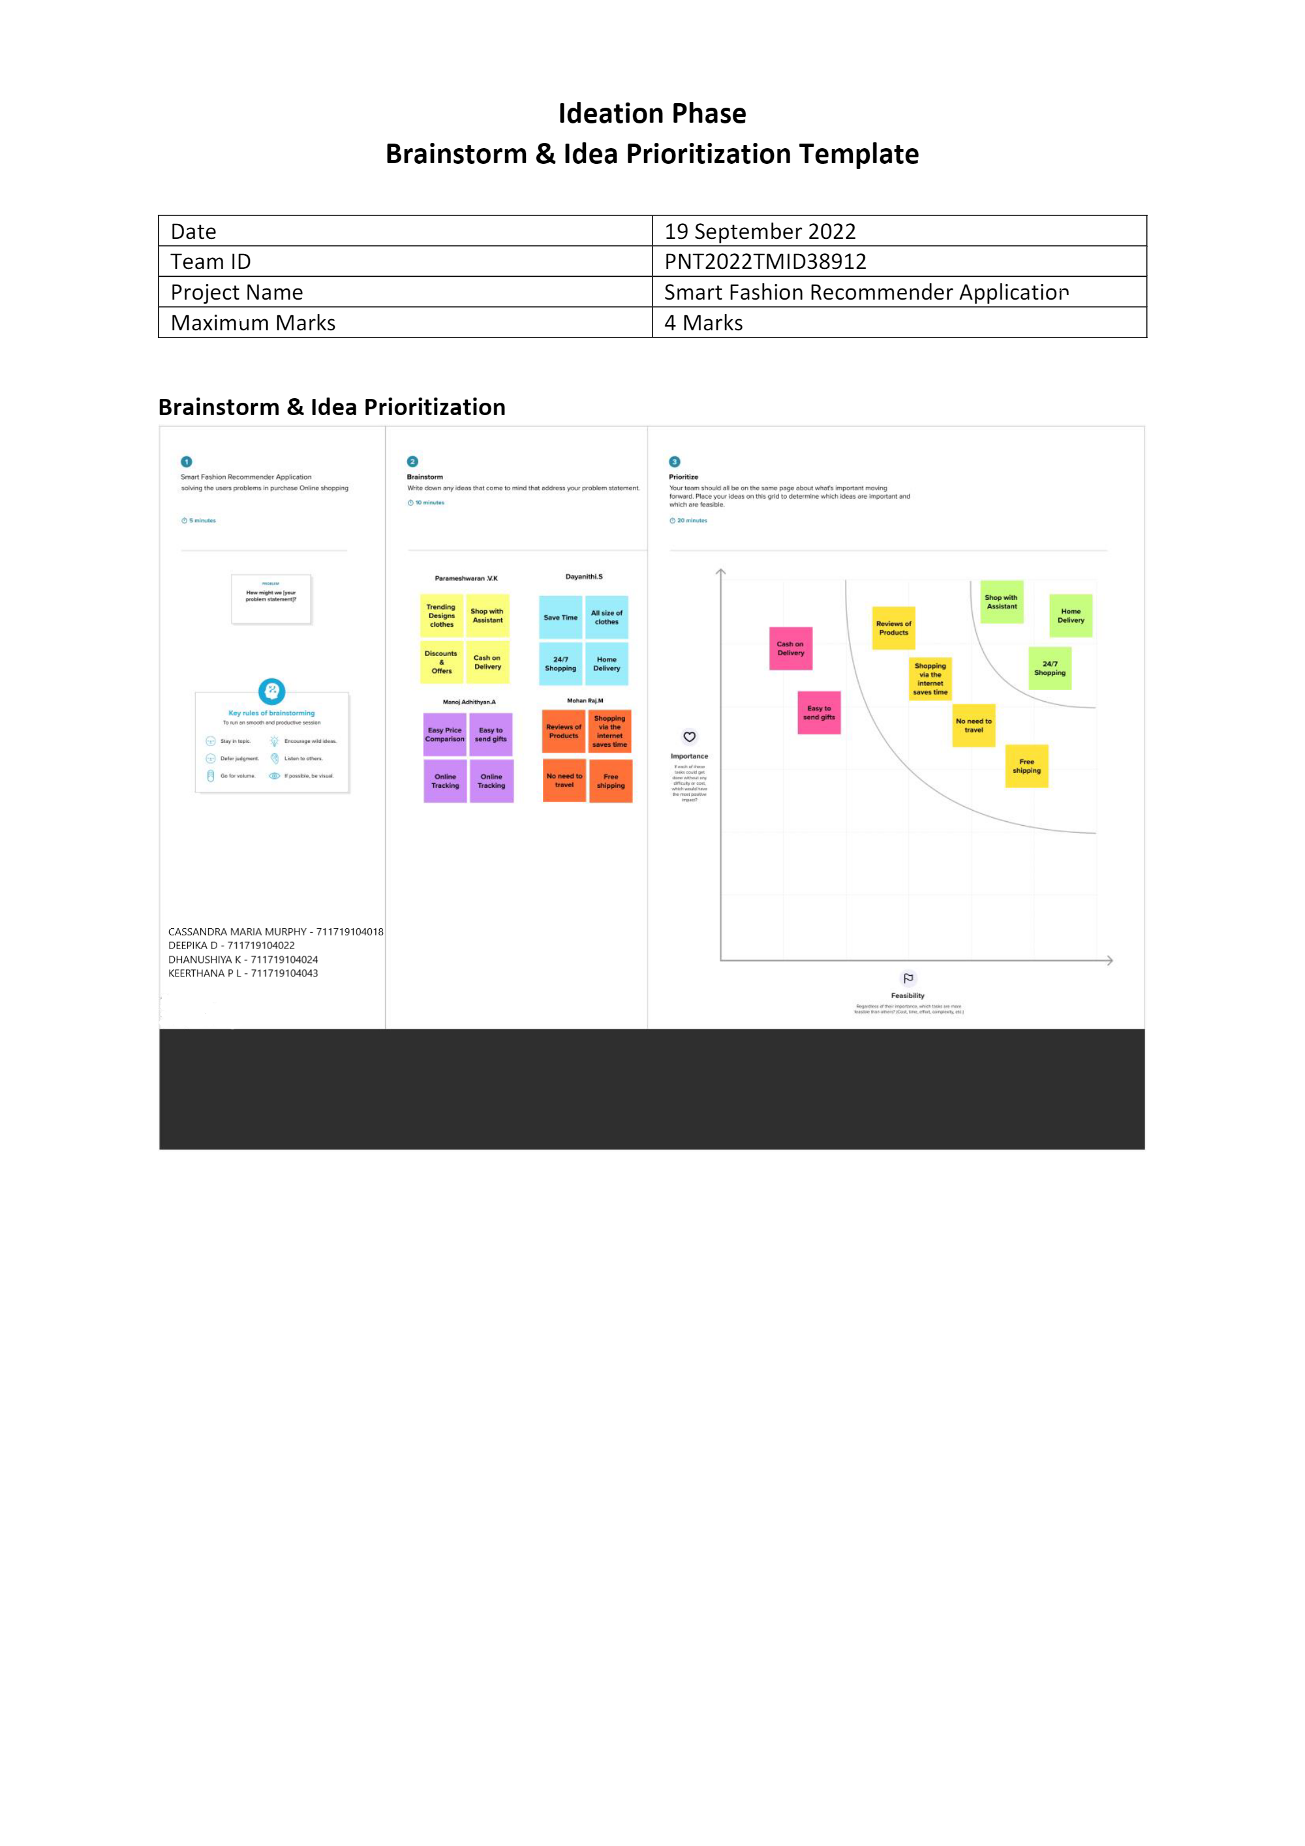

|  |  |
| --- | --- |
| Date | 26 OCTOBER 2022 |
| Team ID | PNT2022TMID31571 |
| Project Name | Smart Fashion Recommender Application |
| Maximum Marks | 4 Marks |